* 1. **How to use this web tool?**

In order to run and use this web tool you need to do some preparations first.

* Install “200 Web Server” : Google Chrome extension (One time task only)

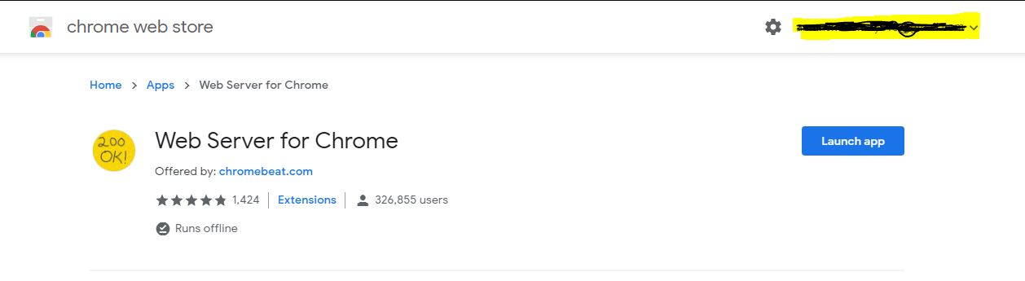

* After installation navigate to “<chrome://apps>” and run the web server. It would look like this:

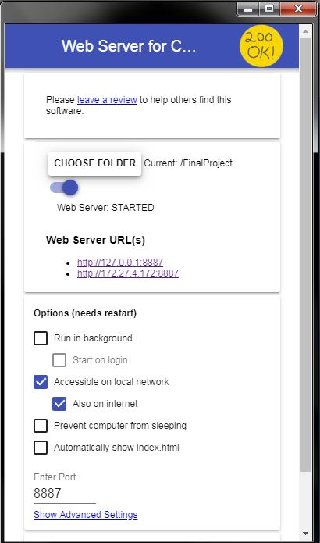Click on **CHOOSE FOLDER** and navigate to the folder containing the web tool (i.e. FinalProject).

Now after **STARTING** the server, click on the URL(s) available and select to launch the web tool.

[**http://127.0.0.1:8887**](http://127.0.0.1:8887) **or**

[**http://172.27.4.172:8887**](http://172.27.4.172:8887)

in my example

(It can be different in your case)

It will display a webpage like shown below:

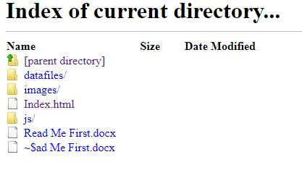

Now click on **Index.html** to display the web tool in your browser.

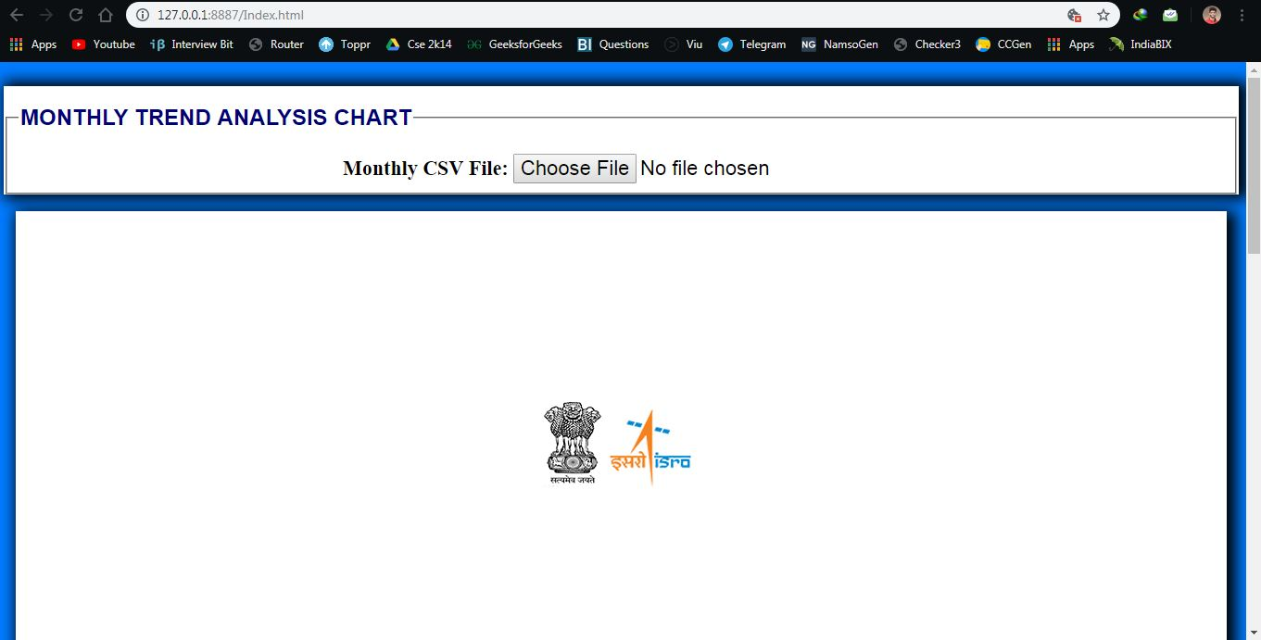

**1.2 Files format of accepted files:**

The required files should be in CSV format (Comma Separated Value available in Excel).

For Monthly and Yearly Data files the file name should me same with suffix MONTHLY and YEARLY for the respective cases.

For example: MONTHLY AGRA LST TREND DATA.csv and YEARLY AGRA LST TREND DATA.csv

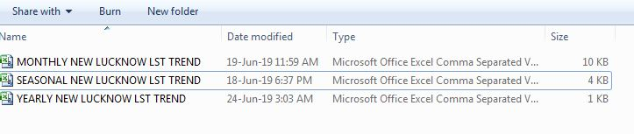

**NOTE:** These files must be present in the datafiles folder available in FinalProject folder. Else the tool would be unable to read files and plot them. *Accessing files at different locations is forbidden by the browser due to security issues.

**1.3 Excel Sheet Formats:**

**MONTHLY CSV YEARLY CSV**

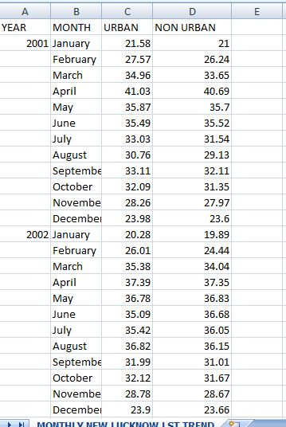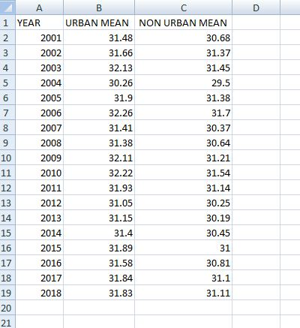

**SEASONAL CSV**

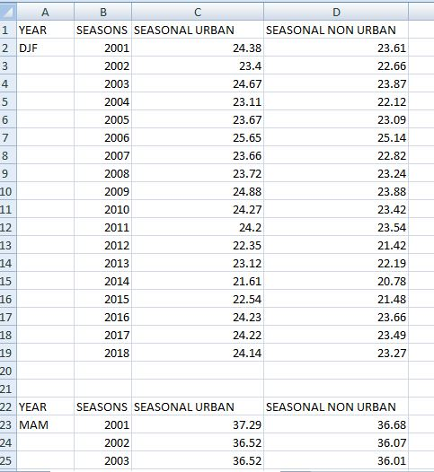

**1.4 Graph Plot Samples:**

